CHAPTER 1

1. Introduction

Steganography is the art of hiding the fact that communication is taking place, by hiding information in other information. Many different carrier file formats can be used, but digital images are the most popular because of their frequency on the Internet. For hiding secret information in images, there exists a large variety of steganographic techniques some are more complex than others and all of them have respective strong and weak points. Different applications have different requirements of the steganography technique used. For example, some applications may require absolute invisibility of the secret information, while others require a larger secret message to be hidden. This project intends to give an overview of image steganography, its uses and techniques. It also attempts to identify the requirements of a good steganographic algorithm and briefly reflects on which steganographic techniques are more suitable for which applications.

Steganography is a method in which you hide the message intended to send to someone in an image. The image might look the same after using steganography but a point to remember is that it has the message. Steganography hides the identity of the message in the cover. The confidential data is taken as input from the user along with the cover image in which the data is to be hidden. These act as an input for the Steganographic Encoder which encodes the given message into the image file, resulting the output as the STEGO-IMAGE. Now the receiver is provided with stego-image which he/she decodes it with the Steganographic Decoder and finally gets the intended message.

1.1 Background Study
The word “Steganography” technically means “covered or hidden writing”. Its ancient origins can be traced back to 440 BC. Although the term steganography was only coined at the end of the 15th century, the use of steganography dates back several millennia.
Some examples of use of Steganography is past times are:
- In ancient Greece, messages were hidden on the back of wax writing tables where someone would peel off the wax that was or written on the stomachs of rabbits.
- In Ancient Greece they used to select messengers and shave their head, they would then write a message on their head. Once the message had been written the hair was allowed to grow back. After the hair grew back the messenger was sent to deliver the message, the recipient would shave off the messengers hair to see the secrete message.
- During World War 2 invisible ink was used to write information on pieces of paper so that the paper appeared to the average person as just being blank pieces of paper. Liquids such as milk, vinegar and fruit juices were used, because when each one of these substances were heated they darken and become visible to the human eye. Invisible ink has been in use for centuries—for fun by children and students and for serious espionage by spies and terrorists.
- Cryptography became very common place in the middle ages. Secret writing was employed by the Catholic Church in its various struggles down the ages and by the major governments of the time. Steganography was normally used in conjunction with cryptography to further hide secret information.
1.2 Literature Survey
Electronic communication is the lifeblood of many organizations. Much of the information communicated on a daily basis must be kept confidential. Information such as financial reports, employee data and medical records needs to be communicated in a way that ensures confidentiality and integrity. This makes good business sense and may even be regulated by legislation like the Health Insurance Portability and Accountability Act (HIPAA). The problem of unsecure communication is compounded by the fact that much of this information is sent over the public Internet and may be processed by third parties, as in e-mail or instant messaging (IM).
Classical steganography techniques involve manipulating the least significant bits of data. For example, "Least Significant Bit (LSB) substitution" replaces the least significant bit of pixel values in an image with secret information. This method was introduced by Provos and Honeyman in their 2003 paper "Hide and Seek: An Introduction to Steganography."
Works like "Digital Watermarking and Steganography" by Cox, Miller, and Bloom provide insights into steganography within multimedia content, including images, audio, and video.
[1] A. Cheddad, J. Condell, K. Curran, and P. M. Kevitt, “Digital image steganography : Survey and analysis of current methods,” Signal Processing, vol. 90, no. 3, pp. 727–752, 2010.
[2] R. Chandramouli, M. Kharrazi, and N. Memon, “Image Steganography and Steganalysis: Concepts and Practice,” in Digital Watermarking, Springer Berlin Heidelberg, 2004, pp. 35–49.
[3] Steganography Method Using Effective Combination of RSA Cryptography and Data Compression by Abhranil Bose; Akshat Kumar; Malaya Kumar Hota; Shubham Sherki as encyption technique \ data compression In 2022 IEEE

[4] A Combination of RSA Algorithm with Image Steganography to Ensure Enhanced Encryption by B. Karthikeyan; B. Bharathkumar; G. Manikandan; R. Seethalaks as RSA \ CRYPTOGRAPHY in 2023 IEEE

[5] File encryption and hiding application based on advanced encryption standard (AES) and append insertion steganography method by Gotfried C. Prasetyadi; Achmad Benny Mutiara; Rina Refianti using technique INSERTION TECHNIQUE \ AES \ File Hiding and Recovery in 2017 IEEE

[6] A new approach for enhancing LSB steganography author Mohammed Al-
Momin, Issa Ahmed Abed, Hussein A. Leftah technique Data embedding
Image processing Information hiding Steganography International Journal of Electrical and Computer Engineering (IJECE) in 2019.

[7] In this paper, we propose a novel technique for hiding arbitrary binary data in images using generative adversarial networks which allow us to optimize the perceptual quality of the images produced by our model from Kevin Zhang Kevin Alex Zhang, Alfredo Cuesta-Infante, Lei Xu, Kalyan Veeramachaneni from cornell university in 2019

[8] This paper discussed recent steganographic techniques for image files. Imperceptibility, embedding capacity and robustness are the key issues of image steganography. These recent techniques are analysed the key issues of steganography and discussed the merits and demerits of these techniques, to identify the suitability for data hiding method which will provide guidance to the people working in this field. Steganalysis was also discussed separately.in January 2015 International Journal of Information and Communication Technology author S. Uma Maheswari and D. Jude Hemanth.
[9] Computer based communications nowadays are at threshold of making our lives easier in the world; from exchanging electronic documents, to communicating with each other, to sharing information ,and to check bank balances and pay bills. Information security is an essential part that must be taken into consideration to ensure communication. Steganography is the technique that restricts the unauthorized users to have access to an important data. By using Steganography, the information can be hidden in the carrier items such as images, sound files, text files, videos while performing the data transmission. Author Vaibhavi Sushil,Abhishek Shahi in 2022.

1.3 Motivation

In digital world cyber-attacks are very frequent. Any social networking site, web application, etc are more prone to attacks. Some of the attacks are given as follows

Ciphertext Only Attacks (COA):
Method: Attacker has ciphertexts but no corresponding plaintext.
Objective: Determine plaintext or occasionally the encryption key.

Known Plaintext Attack (KPA):
Approach: Attacker knows some parts of the plaintext and aims to decrypt the rest.
Example: Linear cryptanalysis against block ciphers.

Chosen Plaintext Attack (CPA):
Strategy: Attacker encrypts chosen text, simplifying the key determination.
Vulnerabilities: Hash functions, block ciphers, and RSA in public key systems.

Dictionary Attack:
Technique: Build a dictionary of ciphertexts and corresponding plaintexts.
Future Use: Reference for finding plaintexts when new ciphertexts are obtained.

Brute Force Attack (BFA):
Approach: Attacker tries all possible keys to decrypt the ciphertext.
Time Complexity: High for longer keys due to attempting every possible combination.

Man in Middle Attack (MIM):
Target: Public key systems involving key exchange before communication.
Process: Attacker intercepts key exchange, reads data, and re-encrypts before passing it on.

1.4 Problem Statement

The problem at hand is to develop and implement advanced steganographic techniques to bolster cybersecurity. This project aims to tackle the following challenges:

- Enhanced Data Concealment: Existing steganographic methods need improvement to enhance the capacity for data concealment within various types of digital media, including images, audio, and video files.

- Resistance to Detection: The steganographic techniques should be designed to be resilient against modern detection methods, including statistical analysis and machine learning algorithms.

- Real-World Applicability: The project should result in practical steganographic tools that can be easily used by individuals, organizations, and cybersecurity professionals to protect sensitive information during digital transmission

- Security Evaluation: A comprehensive evaluation of the security offered by the developed steganographic techniques, including their vulnerabilities and potential attack vectors, is crucial to ensure their reliability in real-world scenarios.

1.5 Aim and Objective

Aim:

To design and implement a robust image steganography system that ensures secure and imperceptible embedding of data within digital images, enabling confidential communication. the project aims to develop a practical, secure, and user-friendly image steganography system that aligns with ethical standards and addresses real-world needs for secure communication and data concealment within digital images.

The primary objectives of the steganography are as follows:

- Developing a method to encode data into a cipher text.
- Developing a method to encode data into a cover image and decode the data from the stego-image.
- Combining these both to form a secured communication system

CHAPTER 2
2.1 Cybersecurity | About Your Domain
The cybersecurity domain is a rapidly evolving field that focuses on safeguarding systems, networks, devices, data, and information from unauthorized access, attacks, damage, or theft. It encompasses various practices, technologies, methodologies, and measures aimed at ensuring the confidentiality, integrity, and availability of digital assets in the face of constantly evolving cyber threats.

Key aspects and components of the cybersecurity domain include:
Threat Landscape: Cybersecurity professionals constantly monitor and analyze the threat landscape, which includes a wide range of cyber threats such as malware, phishing attacks, ransomware, social engineering, DDoS attacks, and more. Understanding these threats is crucial for developing effective defense mechanisms.

Security Measures and Technologies:
Cybersecurity employs various tools, technologies, and practices to protect systems and networks. This includes firewalls, antivirus software, intrusion detection and prevention systems (IDPS), encryption, multi-factor authentication (MFA), secure coding practices, and more.

Risk Management:
Identifying, assessing, and managing risks is a fundamental aspect of cybersecurity. This involves conducting risk assessments, defining risk tolerance levels, and implementing strategies to mitigate or eliminate identified risks.

Compliance and Regulations:
Adherence to legal and regulatory standards such as GDPR, HIPAA, PCI DSS, and others is essential. Compliance ensures that organizations follow specific guidelines and laws related to data protection and privacy.

Incident Response and Management:
Developing incident response plans and procedures is crucial for effectively addressing security incidents or breaches. This includes steps for detection, containment, eradication, recovery, and lessons learned for future prevention.

Security Awareness and Training:
Educating employees and users about cybersecurity best practices, threats, and potential risks is vital. Training programs aim to enhance awareness and promote a security-conscious culture within organizations.

Emerging Technologies and Trends:
With the rapid advancements in technology, emerging trends such as Artificial Intelligence (AI) and Machine Learning (ML) are being utilized in cybersecurity for threat detection, pattern recognition, and automation of security processes.

2.2 Cryptography
Cryptography can be used to provide message confidentiality and integrity and sender verification. The basic functions of cryptography are encryption, decryption and cryptographic hashing. In order to encrypt and decrypt messages, the sender and recipient need to share a secret. Typically this is a key, like a password, that is used by the cryptographic algorithm. The key is used by the sender to encrypt the message (transform it into cipher text) and by the recipient to decrypt the message (reverse the cipher text back to clear text). This process can be done on a fixed message, such as an e-mail, or a communications stream, such as a TCP/IP connection. Cryptographic hashing is the process of generating a fixed-length string from a message of arbitrary length. If the sender provides a cryptographic hash with the message, the recipient can verify its integrity. Modern cryptographic systems are based on complex mathe- matical relationships and processes. Lets focus on the common cryptography standards used to secure computer communications and how they are used.

The three basic types of cryptography in common use are symmetric key, asymmetric (public) key systems and cryptographic hash functions. Typically, the strength of a crypto system is directly related to the length of the key. This assumes that there is no inherent weakness in the algorithm and that the keys are chosen in a way that fully utilizes the key space (the number of possible keys). There are many kinds of attacks that can be used against crypto systems, but these are beyond our scope here. That said, if you use public algorithms with no known vulnerabilities, use reasonable key lengths (most defaults are fine) and choose good keys (which are normally chosen for you), your communications will be very secure.

Cryptography Drawbacks:

Apart from the four fundamental elements of information security, there are other issues that affect the effective use of information:

• A strongly encrypted, authentic, and digitally signed information can be difficult to access even for a legitimate user at a crucial time of decision-making. The network or the computer system can be attacked and rendered non-functional by an intruder.

• High availability, one of the fundamental aspects of information security, cannot be en- sured through the use of cryptography. Other methods are needed to guard against the threats such as denial of service or complete breakdown of information system.

• Another fundamental need of information security of selective access control also cannot be realized through the use of cryptography. Administrative controls and procedures are required to be exercised for the same.

• Cryptography does not guard against the vulnerabilities and threats that emerge from the poor design of systems, protocols, and procedures. These need to be fixed through proper design and setting up of a defensive infrastructure.

• Cryptography comes at cost. The cost is in terms of time and money 1. Addition of cryptographic techniques in the information processing leads to delay. 2. The use of public key cryptography requires setting up and maintenance of public key infrastructure requiring the handsome financial budget.

• The security of cryptographic technique is based on the computational difficulty of mathe- matical problems. Any breakthrough in solving such mathematical problems or increasing the computing power can render a cryptographic technique vulnerable.

2.3 Steganography
Steganography aims to hiding information in a cover data in such a way that non-participating persons are not able to detect the presence of this information by analyzing the information detection. Unlike watermarking, steganography does not intended to prevent the hidden in- formation by opponents of removing or changing the hidden message, which is embedded in the cover data but it emphasizes on remains it undetectable. Steganography is particularly interesting for applications in which the encryption can not used to protect the communication of confidential information.

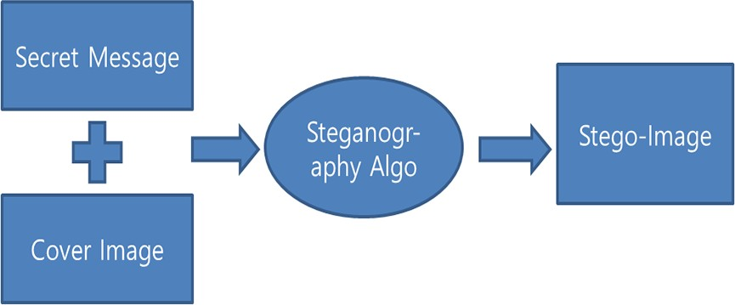
Figure 1: PROCESS OF STEGANOGRAPHY

CHAPTER 3
3.Methodology
1. Image Preprocessing:
Load the cover image and convert it into a suitable format for manipulation (e.g., using Pillow library).

2. Encryption:
Encrypt the secret message/data using AES encryption and a secret key.
Encrypt the AES secret key using RSA encryption with a public key.

3. Embedding:
Apply the LSB technique to hide the encrypted AES key and the AES-encrypted message within the cover image. Alter the least significant bits of selected pixels in the image to embed the encrypted data.

4. Save or Transmit the Modified Image:
Save the modified image with the hidden encrypted data.
Transmit or store the modified image as required.

5. Extraction:
Load the modified image that contains the hidden encrypted data.

6. Decryption and Retrieval:
Extract the hidden encrypted data by retrieving the LSB-altered bits.
Decrypt the AES key using RSA private key.
Decrypt the secret message using the obtained AES key.

Python Libraries:
Use PIL or Pillow for image manipulation.
PyCryptoDome can be used for AES and RSA encryption/decryption.

Steps Overview:
Load the cover image and preprocess it.
Encrypt the secret message using AES and generate a secret key.
Encrypt the AES secret key using RSA public key encryption.
Embed the encrypted data (AES key and message) into the cover image using LSB technique.
Save the modified image.
To extract, load the modified image and reverse the process.
Extract the LSB-altered bits.
Decrypt the AES key using the RSA private key.
Decrypt the hidden message using the obtained AES key.
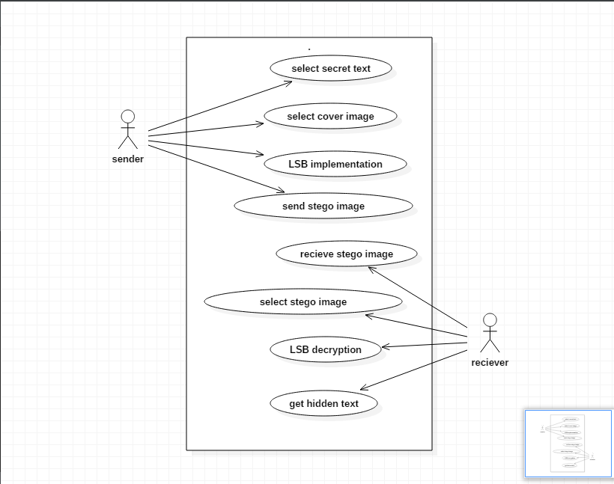
This methodology involves combining image processing techniques (LSB) with encryption ( AES, RSA) to securely hide and extract information within images using Python.

Figure 2. Usecase Diagram

3.1 Existing system

The implementation has been done majorly in two phases here that is cryptography implementation and steganography implementation. These two major phases have more sub- phases in them for implementation.
A GUI is developed using Python PySimpleGUI. which includes four layouts namely: Encrypt, Decrypt, Keys, Mail. For the implementation of cryptography, firstly we need to generate the keys to procced further. So, the first part of the implementation is the GENERATING OF KEYS. In the KEY layout the user is asked for selecting the key size and output folder. It has a button Generate keys, which on clicking generates the pair of keys to the output folder selected.The key generation code is implemented by the following code. The key is generated using the function .generate() embedded in the Crypto.Cipher and Crypto.PublicKey package.

from Crypto.Cipher import AES, PKCS1_OAEP from Crypto.PublicKey import RSA

def GenerateKeyPair(dir = '', size = 3072): keyPair = RSA.generate(size) privateKey = keyPair.export_key()
with open(dir + '/' + str(size) + '_private.pem', 'wb') as outputFile: outputFile.write(privateKey)

publicKey = keyPair.publickey().export_key()
with open(dir + '/' + str(size) + '_public.pem', 'wb') as outputFile: outputFile.write(publicKey)

Once the keys are generated, we can proceed for the encryption process. Coming to layout Encrypt, the user is given various choices for encrypting, the choices include:

* to perform only symmetric cryptography
* to perform only asymmetric cryptography
* to perform symmetric cryptography and steganography
* to perform asymmetric cryptography and steganography
* to perform only steganography

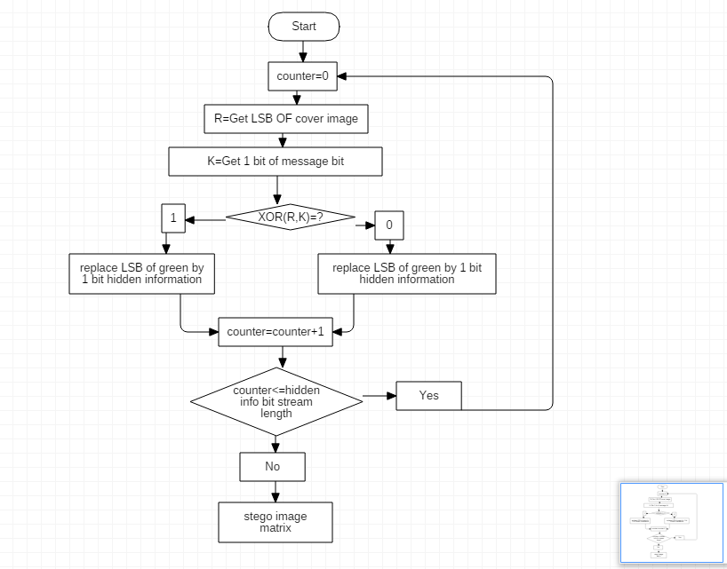
Figure 3: Encryption Diagram

Coming to layout Decrypt, the user is given various choices for decrypting, the user is asked for the encrypted file, the key and the desired output folder. It also has a textbox where the decrypted data and the confirmation if it is decrypted or not is displayed once we click the decrypt button.

#CODE FOR DECRYPTION USING RSA
def DecryptRSA(encrypted, privateKey): decryptor = PKCS1_OAEP.new(privateKey) decrypted = decryptor.decrypt(encrypted) return decrypted

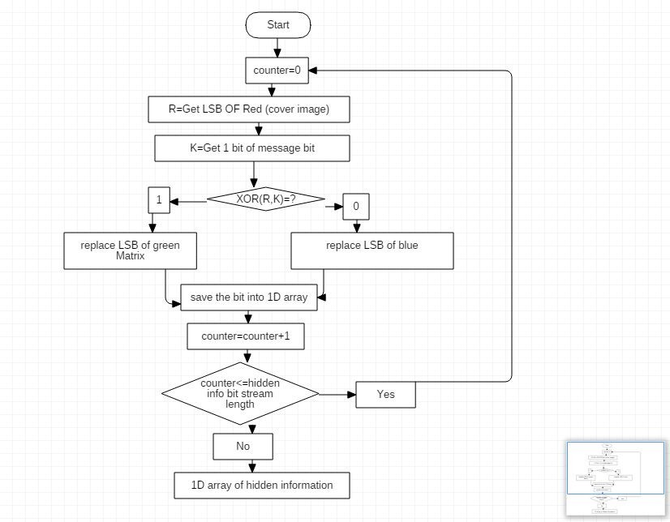

Figure 4: Decryption Diagram

Now looking at the mail layout, the main function of it is to transfer the encrypted file to the receiver where the user is asked for encrypted file, his email address and password and the email of the receiver. Once clicked send mail the mail is sent with the encrypted file attached to it. The code implementation of sending mail is as follows

smtpObj=smtplib.SMTP_SSL("smtp.gmail.com",465)
#smtpObj.login("admin123@gmail.com","admin123") #smtpObj.sendmail('admin123@gmail.com','admin789@gmail.com','encrypted. txt')
smtpObj.login(values['sender_addr'],values['mail_pwd']) smtpObj.sendmail(values['sender_addr'], values['mail_addr'], message)
smtpObj.quit()

3.2.PROPOSED SYSTEM

i) Overview:
- A GUI is developed by a secure communication system using concepts of cryptography and steganography with three objectives in mind:
1. Developing a method to encode data into a cipher text.
2. Developing a method to encode data into a cover image and decode the data from the stego- image.
3. Combining these both to form a secured communication system.

ii) Algorithms used:
The proposed system deals with the cryptographic and steganographic algorithms. In our system, for symmetric cryptography technique we used RSA algorithm, and for asymmetric cryptography we used AES algorithm. And coming for steganography we used the LSB technique.

AES ALGORITHM:
It is a symmetric algorithm. Where the key is the same for both the sender and the receiver. It works on block cipher technique which means that size of the plain text and cipher text must be the same. Here an input key is given into the algorithm which is of the same size as the plain text. The working of AES algorithm is as simple as stated. There are basically, three types of bits that support this algorithm: 128 bits, 192 bits and 256 bits. It states that the algorithm has multiple rounds which are for processing the key lengths. The number of rounds depends on the key size being used. A 128-bit key size dictates ten rounds, a 192-bit key size dictates 12 rounds, and a 256-bit key size has 14 rounds. Steps in each round are:
- Substitution of the bytes: the bytes of the block text are substituted based on rules dictated by predefined S-boxes • Shifting the rows: all rows except the first are shifted by one
- Mixing the columns: the Hill cipher is used to jumble up the message more by mixing the block’s columns.
- Adding the key round: the message is XORed with the respective round key. The model mentioned above just inverses itself when decrypting.

RSA ALGORITHM:
RSA is a block-cipher type algorithm that converts plain text to cipher text. The RSA algorithm is an asymmetric cryptography algorithm; this means that it uses a public key and a private key. As their names suggest, a public key is shared publicly, while a private key is secret and must not be shared with anyone

LSB TECHNIQUE ALGORITHM:
In LSB steganography technique, the information hider embeds the secret information in the least significant bits of a media file. In an image file each pixel is comprised of three bytes of data corresponding to the colours red, green, and blue. The pixel value is converted to binary. The confidential data is converted to its binary format and a temporary variable is assigned to null. If the message bit and LSB of the pixels are found similar then temporary variable is assigned to 0 and if different it is set to 1. The setting of temp is done by considering XOR of message bit and the LSB of the pixel by updating the pixel of output image to input image pixel value and summation of the temporary variable.

iii) System Architecture
The main architecture of the process for communication between 2 parties is as follows
- The sender selects a cover image for encoding the message in it.
- The sender encrypts the confidential data with suitable cryptographic algorithms and encodes the encrypted data in the cover image with a public key using LSB technique and transmits it to the receiver on an unreliable channel.
- The receiver receives the stego-image through email and decodes the encrypted text from it using the private key.
- Encrypted text is decrypted using the same cryptographic algorithm & confidential message.
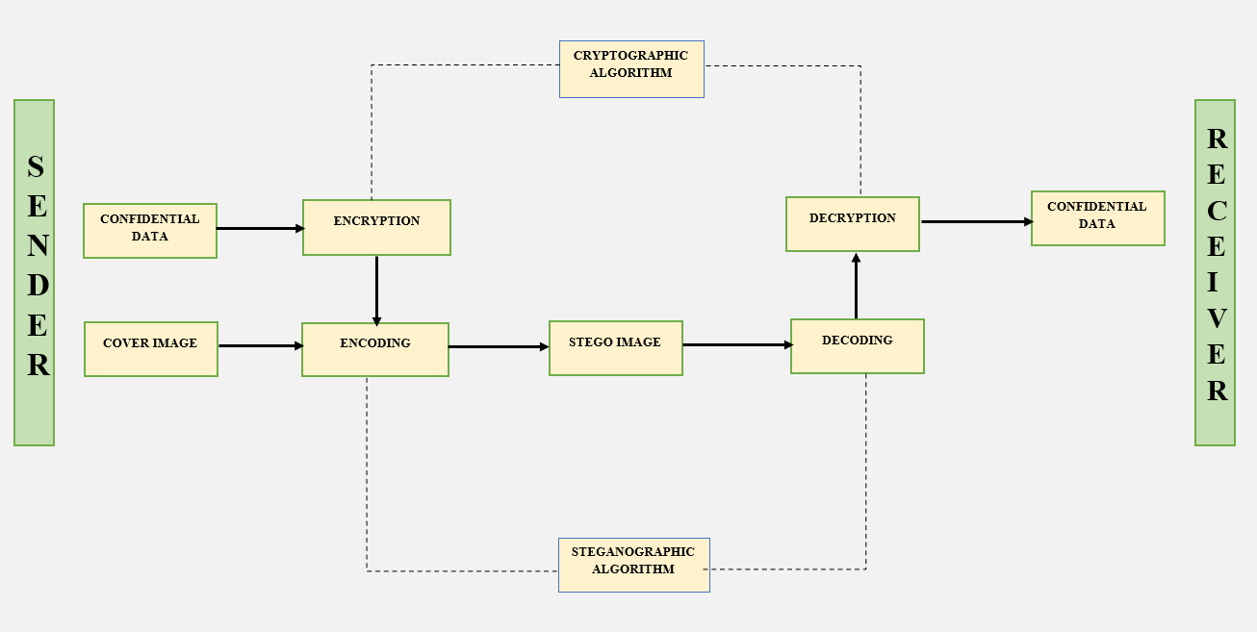

Figure 5 .Architecture

CHAPTER 4
System requirement specification
4.1 General description
The project aims to develop a Python-based image steganography system that combines Advanced Encryption Standard (AES), Rivest–Shamir–Adleman (RSA), and Least Significant Bit (LSB) algorithms. This system facilitates the secure hiding and extraction of confidential data within digital images while maintaining the cover image's visual integrity.
The image steganography system employs a combination of cryptographic techniques and LSB-based embedding to ensure the confidentiality and security of hidden data within images. The project involves the following key components and functionalities:

Image Handling and Preprocessing:
Capability to load and preprocess cover images in various formats (e.g., JPEG, PNG).
Image preprocessing steps to prepare images for LSB-based data embedding without significant visual distortion.

Encryption Algorithms:
Implementation of AES encryption to secure the confidential message or data.
Usage of RSA encryption to protect AES keys used for encrypting and decrypting hidden data.

Steganographic Embedding:
Integration of the LSB algorithm to embed encrypted data within the cover image.
Precise manipulation of least significant bits of selected pixels to hide the encrypted information without visibly altering the image.

Data Handling and Security Measures:
Support for handling text or binary data as secret messages, ensuring flexibility for various data types.
Robust implementation of encryption algorithms (AES and RSA) to ensure the security and confidentiality of hidden data.

User Interface (Optional):
Potential inclusion of a user-friendly interface (optional) to enhance user interaction. Features may include image selection, input for secret messages, and initiation of encryption/decryption processes.

Compatibility and Portability:
Cross-platform compatibility to ensure the system works seamlessly on different operating systems and Python environments.

Documentation and Support:
Comprehensive documentation detailing system functionalities, usage guidelines, and algorithm implementation. Provision of support resources for users to troubleshoot issues or understand the system's operation.

4.1.1System objectives
Image Handling:
Data Security and Confidentiality:

Objective: Implement robust AES and RSA encryption techniques to ensure secure and confidential transmission of hidden data within images.

Steganographic Capacity and Integrity:
Objective: Enable embedding and extraction of data without perceptible degradation of the cover image quality or integrity.

Functional Efficiency:
Objective: Provide efficient encryption, embedding, and extraction processes for seamless and effective steganographic operations.

Usability and User Interface:
Objective: Offer a user-friendly interface (optional) for users to interact with the system, allowing easy selection of cover images, entering messages, and performing steganographic operations.

Algorithm Implementation:
Objective: Integrate AES, RSA, and LSB algorithms coherently, ensuring proper encryption, embedding, and extraction functionalities.

Cross-Platform Compatibility:
Objective: Ensure compatibility with multiple operating systems (Windows, macOS, Linux) and various Python environments for broader accessibility.

Documentation and Support:
Objective: Provide comprehensive documentation detailing system functionalities, usage guidelines, algorithms implemented, and troubleshooting steps. Offer user support for queries and issues related to the system.

Testing and Validation:
Objective: Conduct rigorous unit testing to verify the functionality of encryption, embedding, and extraction processes. Perform user acceptance testing (UAT) to ensure usability and alignment with user expectations.

Performance Optimization:
Objective: Optimize system performance to handle varying image sizes and data capacities efficiently. Minimize impact on image quality after embedding data.

Risk Mitigation:
Objective: Identify and mitigate potential risks related to resource limitations, algorithmic constraints, and security vulnerabilities

CHAPTER 5

System requirements
5.1.Functional requirements
Functional requirements are the requirements that that define specific behavior or function of the system. Ability to load cover images in common formats (JPEG, PNG, etc.). Preprocessing of images for LSB embedding (e.g., resizing, normalization).

Encryption and Decryption:
Implement AES encryption and decryption for securing the message.
Implement RSA encryption and decryption for securing AES keys.

Steganographic Embedding:
LSB embedding algorithm implementation for hiding encrypted data within images. Capable of embedding data without perceptible distortion to the cover image.

Data Handling:
Capability to handle text or binary data as secret messages.
Ensure the system handles various message lengths.

User Interface (Optional):
A user-friendly interface for selecting cover images, entering messages, and performing steganographic operations.

5.1.2.Non-Functional Requirements:

Security:
Strong encryption algorithms (AES, RSA) implementation.
Protection against attacks aimed at uncovering hidden data.

Performance:
Efficient encryption and decryption processes.
Minimal impact on image quality after embedding the data.

Scalability:
Ability to handle images of varying sizes.
Support for embedding larger amounts of data if required.

Compatibility and Portability:
Compatibility with multiple operating systems (Windows, macOS, Linux).
Code portability across different Python environments and versions.

Documentation and Support:
Comprehensive documentation detailing the system's functionalities, usage, and algorithms implemented. Support for users to troubleshoot issues or understand the codebase.

5.2. Software Specifications
• Operating System:Windows 7,8,10,11
• Front End : Python
• Tool: pycharm

5.3 Hardware Specifications

• INTEL I5 2.50 GHZ 4 GB RAM
• Minimum Hardware Requirement: Pentium 3 166 MHZ
Or Higher 128 mb RAM

Conclusion
From the whole study, we conclude that using both steganography and cryptography together refers to secure information and communication technique. The GUI implementation for the whole system giving choice to the user to choose his preferable technique for secure communication is added as a part of innovative idea to it. Considering the future work, the application can be further improved by adding some more utilities and designing abetter UI. Some features like providing more crypto algorithms like DES, Blowfish, SA etc. for encryption of the message can provide more utilities to the application. Overall, the present application is very handy, secured and interactive providing sufficient utilities to the users.

References:
[1] .Chowdhury, Z.J., Pishva, D. and Nishantha, G.G.D. (2010) AES and Con - dentiality from the Inside Out. The 12th International Conference on Advanced Communication Technology (ICACT), 2, 1587-1591.
[2]. Rege, K., Goenka, N., Bhutada, P. and Mane, S. (2013) Bluetooth Commu-nication Using Hybrid Encryption Algorithm Based on AES and RSA. Interna- tional Journal of Computer Applications, 71, 10-13
[3]. Bluetooth Security White Paper. Bluetooth SIG Security Expert Group.Downloadable from: (last visited: May 26, 2017) http://grouper.ieee.org/groups/1451/5/Comparis on
[4]. https://en.wikipedia.org/wiki/Cryptography
[5]. http://ijcsn.org/IJCSN-2017/6-3/A-Literature-Survey-on-Efficiency-and-Security-ofSymmetric-Cryptography.pdf
[6]. http://www.ijsrp.org/research-paper-0718/ijsrp-p7978.pdf
[7]. https://www.ijcsmc.com/docs/papers/August2016/V5I8201615.pdf

